Tableau Hand-On Exercises
For Healthcare Providers

Overview 2
Exercise 1 – Connecting to Data 3
Exercise 2 – Exploring the Data 4
Exercise 3 – Geographic Analysis - Maps 7
Exercise 4 –Time Series Analysis 8
Exercise 5 – Telling a Story – Dashboards and interactivity 9

Overview
You will be playing the role of a Data Analyst tasked with identifying where your provider is missing a Length of Stay target of 4.1 days.  - Need to understand which of our facilities are off target  - Which departments are missing goals?  - How we can reduce this KPI  - Ultimately, I’d like to then present my findings with my team and management. | 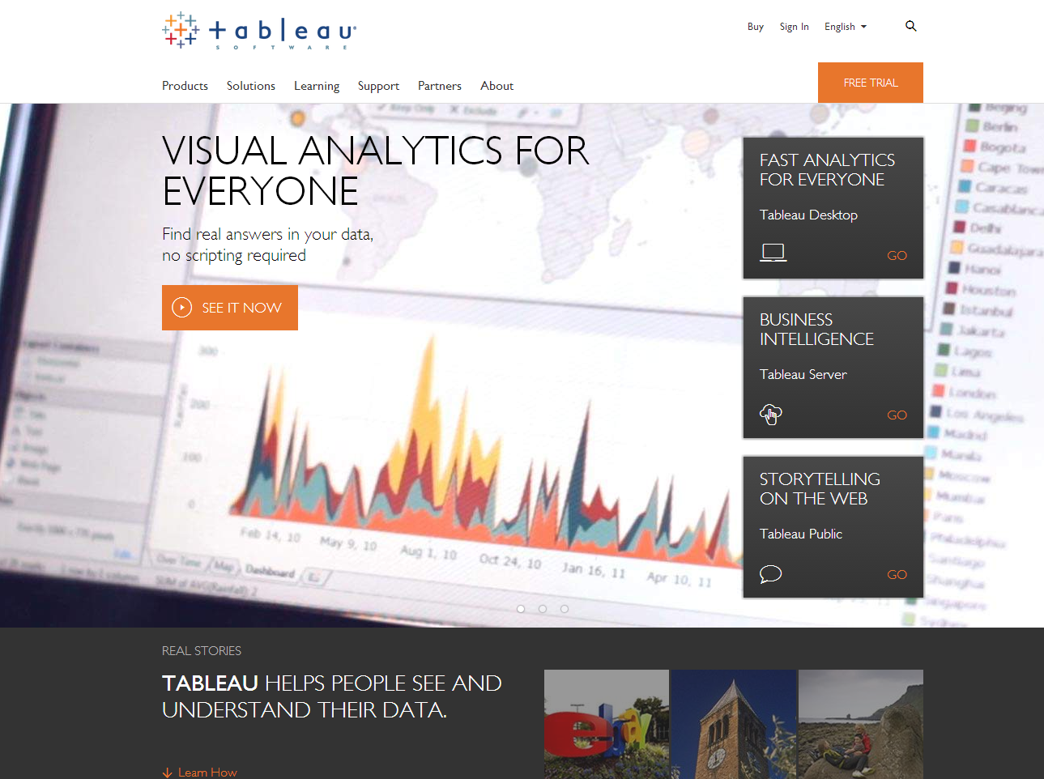

Exercise 1 – Connecting to Data
We will start with our first step to any analysis- connecting to data. Luckily, we are working with a simple .xls file.  Launch Tableau Desktop.  Select ‘Excel’ under connections.  Navigate to where you saved our sample data titled – ‘Length of Stay Workshop Data’  Drag the Sheet into the white space to the right.  Click the orange Sheet 1 tab. | 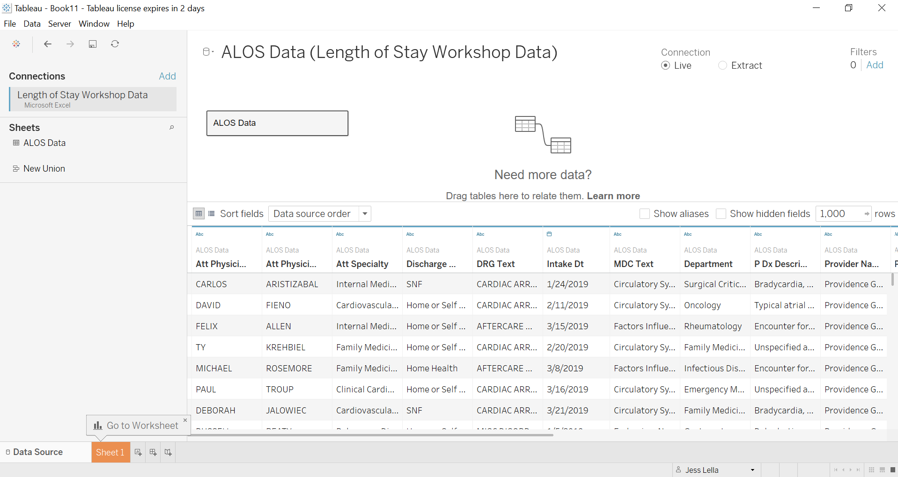
Tableau Desktop Workspace

Tableau organizes and categorizes your data for you. Measures are the numeric data elements – the things you add, average, or otherwise do calculations on. Think of them as the “numbers”, these will always be at the bottom

Dimensions are the (typically) non-numeric data elements – they are the things you group by or drill down by. Think of them as the “words”.
Marks Card
Filters
Pages
Column Shelf
Row Shelf

Exercise 2 – Exploring the Data
Let’s first get a high-level overview of our KPI – Length of Stay.  Double-click on ALOS.  But that doesn’t seem right, notice Tableau is by default using a SUM() aggregation. What we really want is an Average or AVG() aggregation.  Drag Alos off of Rows  Find Alos in your data pane, right click and find menu option Default Properties -> Aggregation and select Average  Now, double click on Alos  There are a few facilities in our care network. I need to find which facilities are missing our goal of 4.1 days.  Double Click on Provider Name  Tableau made a bar chart, but it’s a little hard to see, could there be a better way of visualizing this?  Find Show Me in upper right corner, toggle to a few different visualization types. Ultimately land on the Tree Map  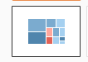  (Note- Tableau has unlimited back button and Ctrl+Z)  I’d also like to see my numbers more clearly.  Now, drag+ drop Alos on top of Label on Marks  Save this Sheet as ‘Facility Length of Stay’ | 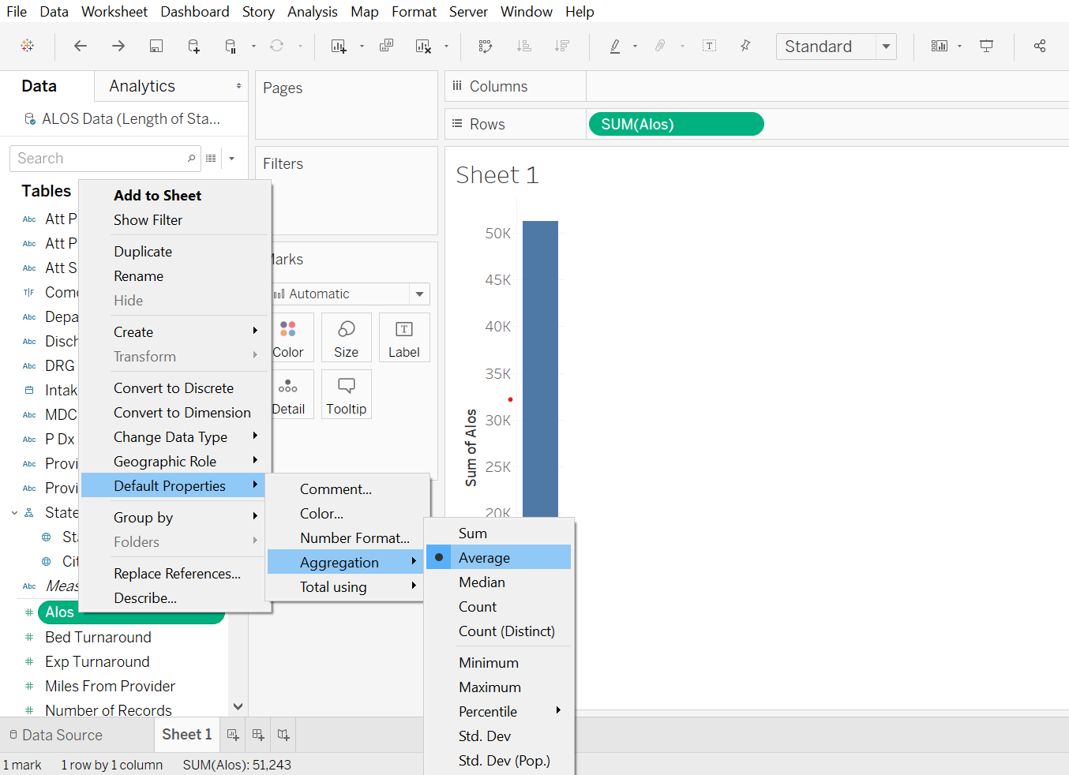  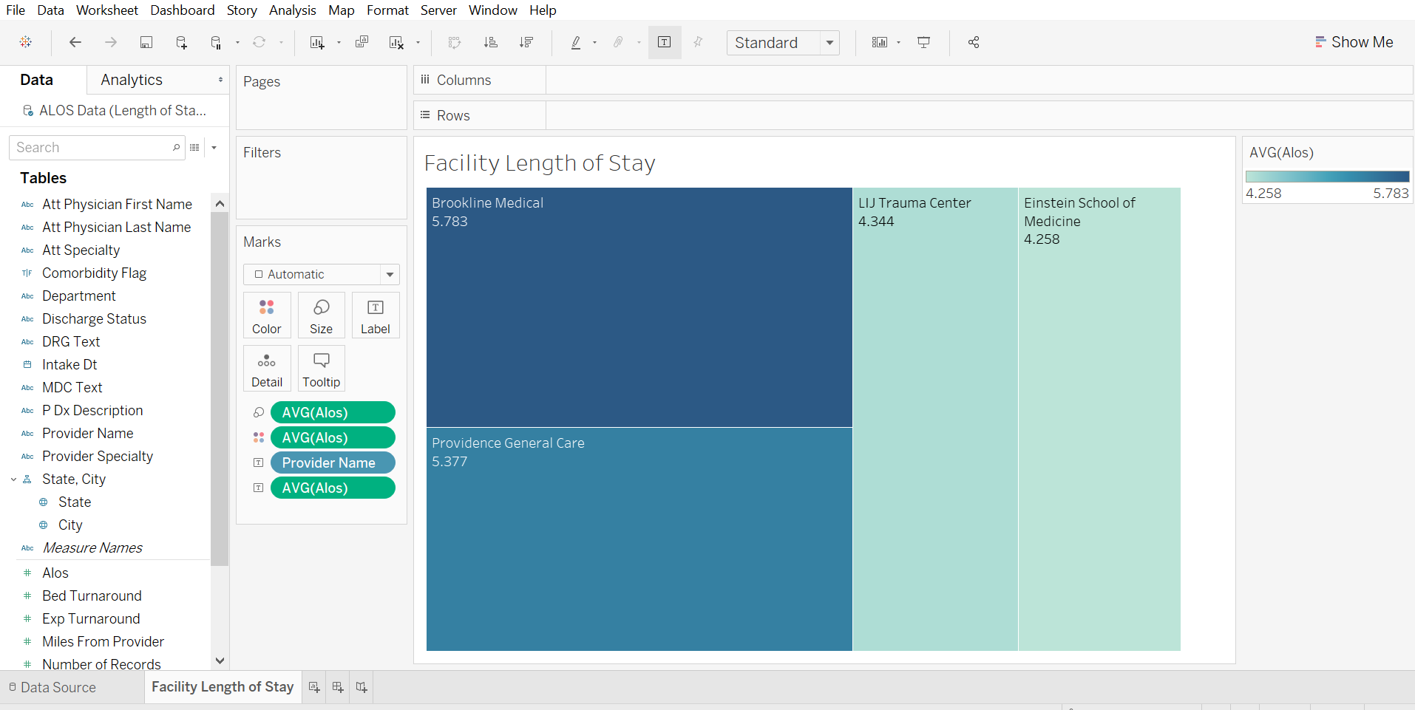
Now, I want to dig deeper, are there specific Service-lines causing our providers to be off target?  Open a new Sheet. Double Click on Department.  It seems we have the same Department (Acute Care) repeated due to naming conventions. Let’s group those.  Click into ACare Dept, hold your ‘ctrl’ key and click down to grab all 3 instances. Right click and Select Group (paperclip icon). Right click on your new group to find Edit Alias and change the name to Acute Care  Note in your Data Pane that your group just created a new dimension  Which Departments have a high Alos?  Click+Drag Alos to Columns  Let’s sort this.  In axis or at top of your screen click to Sort descending  But we are only interested in areas where we are off our goal of 4.1 days…  Click and select the 7 Departments where Alos is over 4 days, choose to Keep Only  Notice that you just created a filter. Let’s customize this filter so it behaves how we want.  Navigate to Filter Shelf, Right Click on Department(group) to Show Filter.  Find your filter flushed right, there will be a small drop down arrow in upper right corner to expand a menu list.  Select Apply to Worksheets -> All Using This Data Source  Optional – Choose Multiple Values (dropdown)  I’d also like to see if certain providers are missing the target more than others in these Departments.  This time, drag + drop Provider Name on top axis till you see a dotted line and release the field  I also want my outliers to jump out immediately, color is a great way to do this.  Drag Alos to Color on Marks  Lastly, drilling into details is key to understanding our issues. We can make a hierarchy to drill into specifics of procedures in each Department.  Find DRG Text in data pane, drag+drop it right on top of the Department (group) that you just created. Rename this “Dept Drilldown”  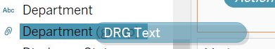  *Bonus – Can you add a constant line of 4.1 days (hint Analytics Tab)  Save this sheet as ‘Off Target Depts’ | 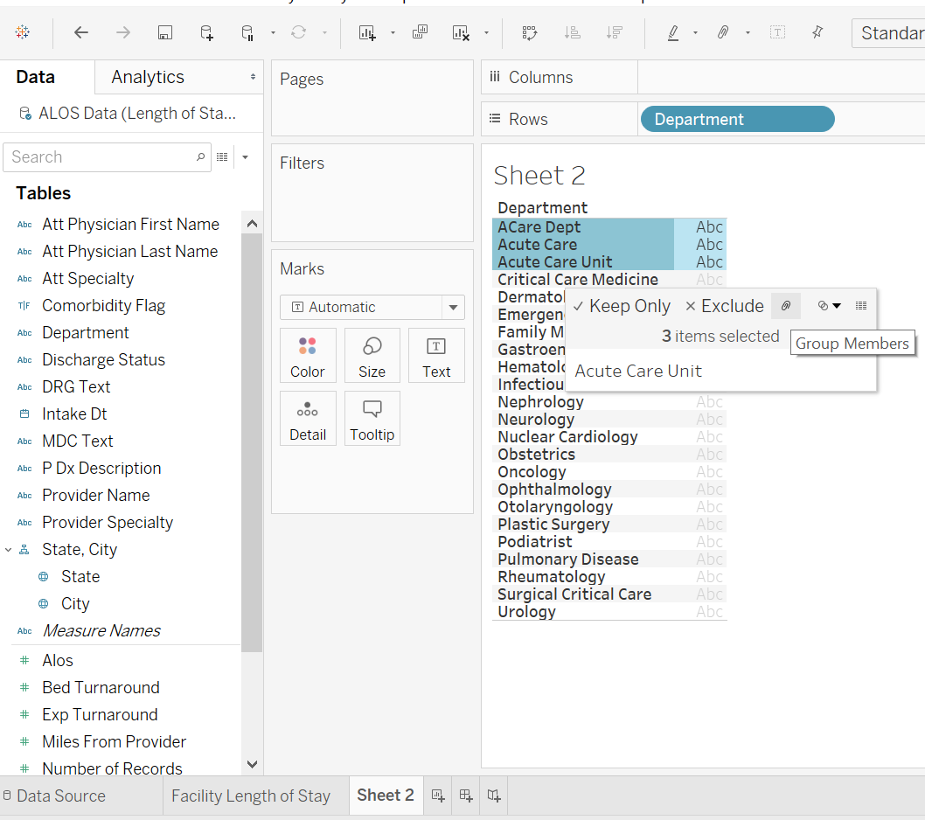  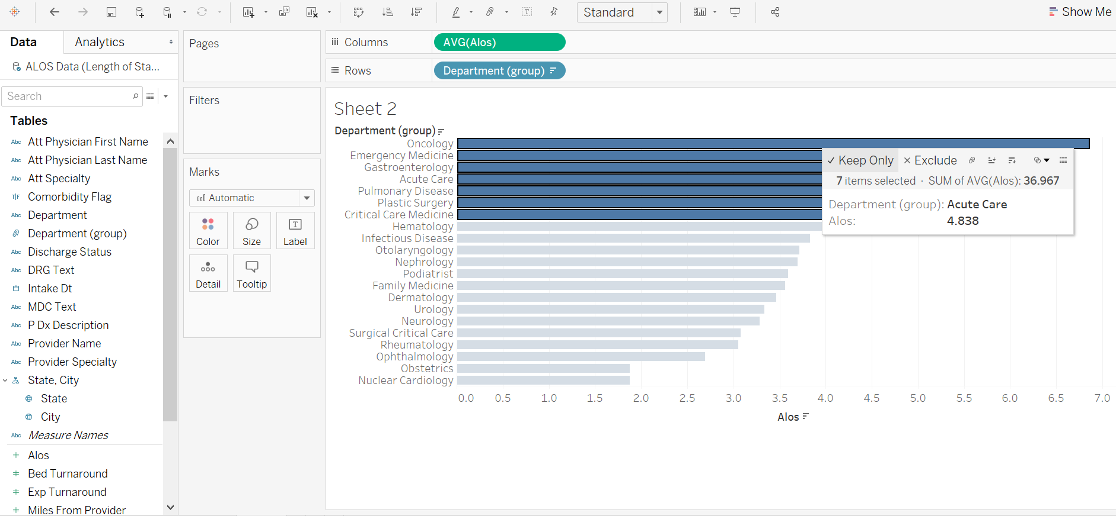  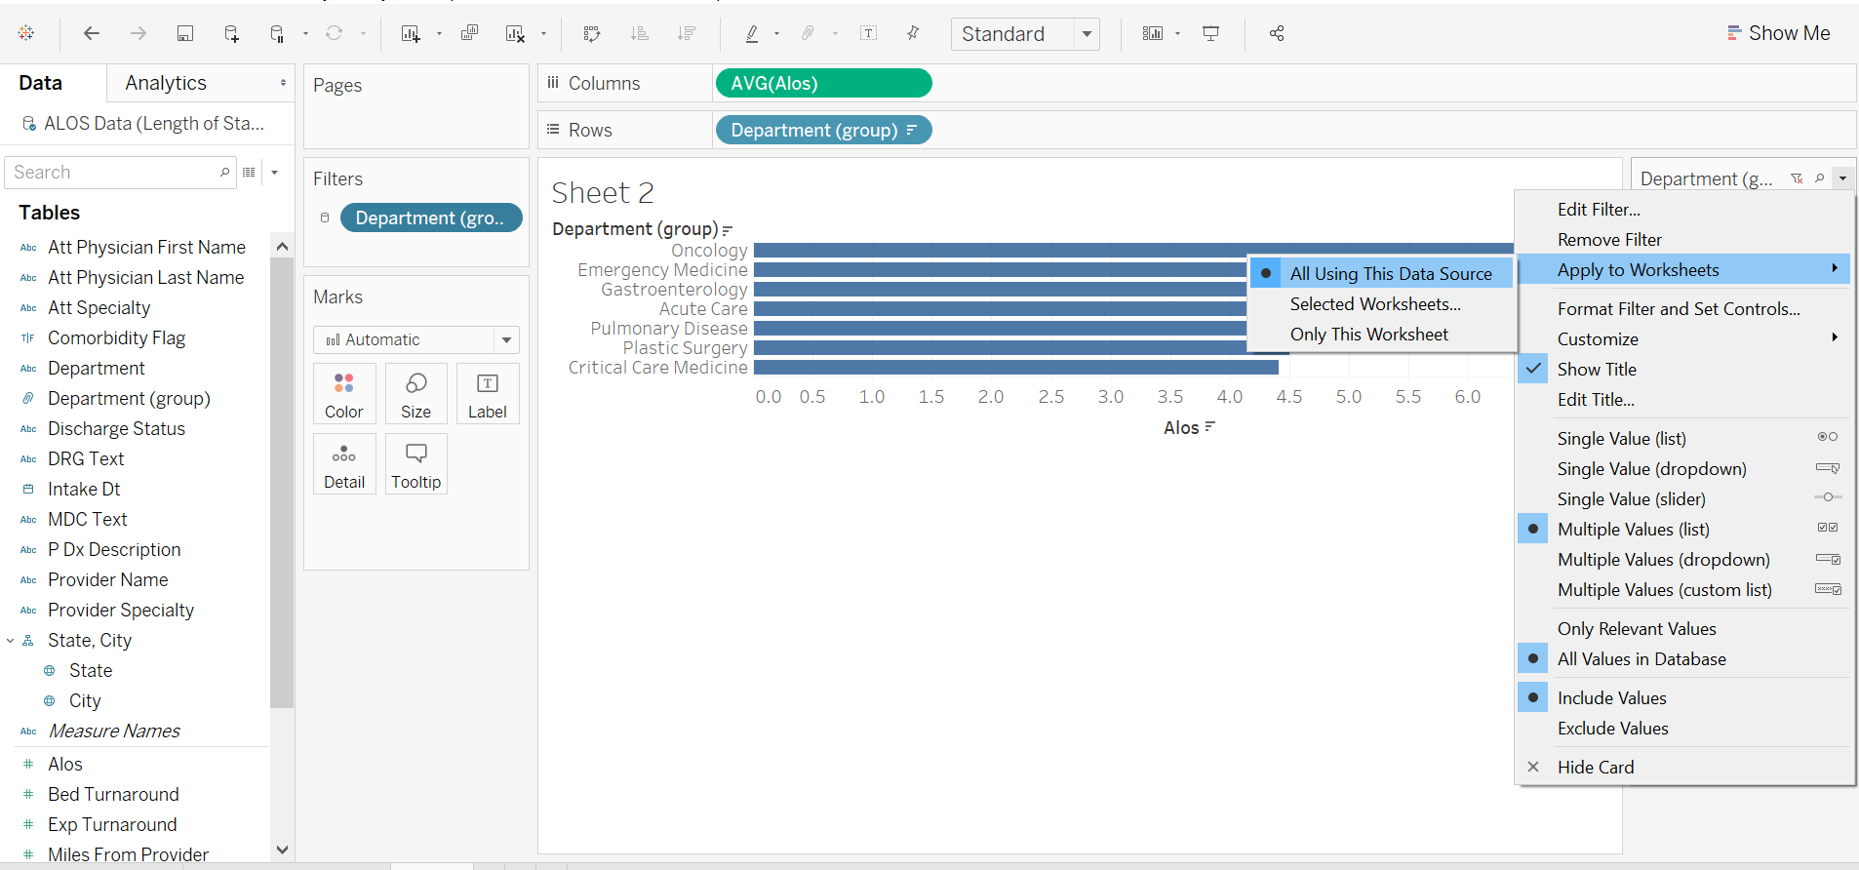  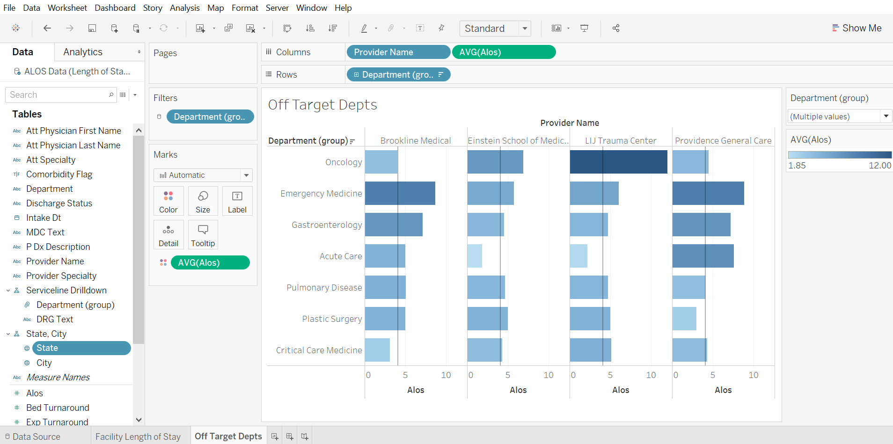

Exercise 3 – Geographic Analysis - Maps
It’s also important that we have a geographic overview of our facilities and satellite locations.  Open a new worksheet and double click on State  No special processing of our data is required – Tableau does this on the fly. We recognize countries, provinces, states, cities, zip codes, etc.  You’ll notice a little globe symbol next to State. This means Tableau automatically sees geographic information in these fields.  Now double click on City  Again, I want any outliers to jump out to my end users. I also want to focus my efforts in areas where we are seeing the most patients.  Drag + drop Alos to Color on Marks  Drag + drop Number of Records to Size on Marks  Use slider to adjust size  Bonus- can you change your map background? (Hint Map Tab)  Save Sheet as ‘Facility Locations’ | 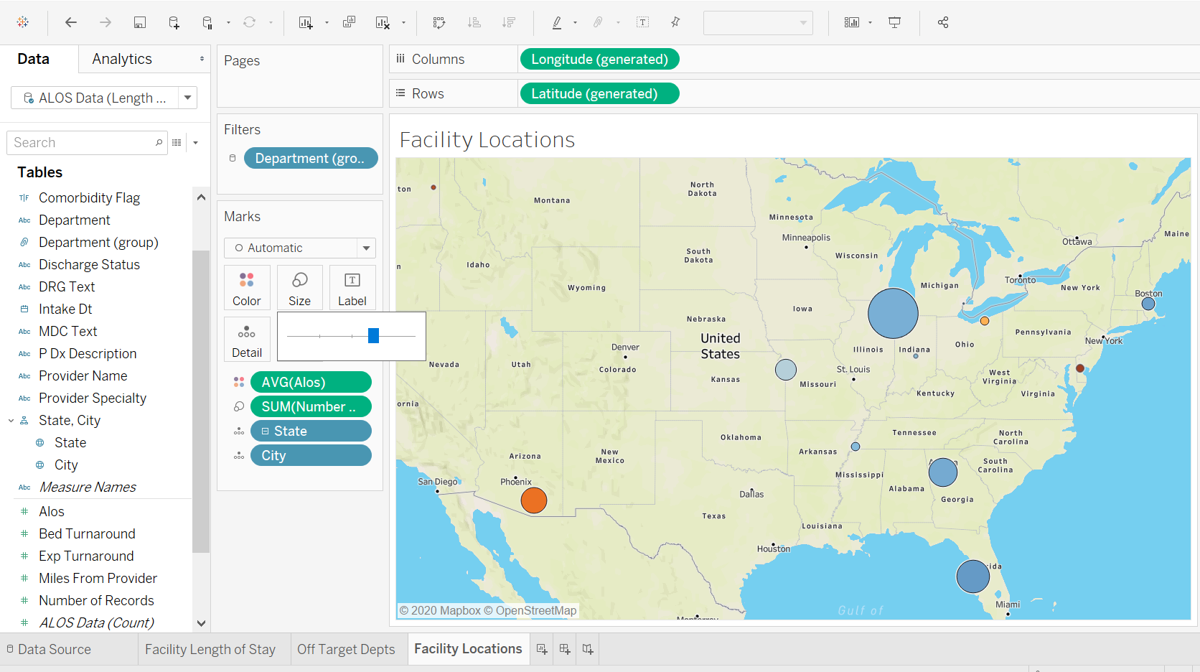

Exercise 4 –Time Series Analysis
Our last analysis is to trend our Alos metric. We want to ensure there are no outliers or uptick trends.  Open a new worksheet.  Double-click on ALOS  Watch what happens when we add a date to the viz.  Double-click on Intake_Dt  This just saved us a lot of work –  - It changed to a line chart because we are now looking at trend data and line charts are best for this.  - It has automatically aggregated our metric by year.  Right-click on the Year field to drop down the menu.  We will choose a continuous Month( 2nd month option) meaning we will trend for each data point aggregating up to Month . Note that discrete dates are built-in hierarchies in Tableau.  Optional- choose Area on Marks  Save sheet as ‘ALOS Trend’ | 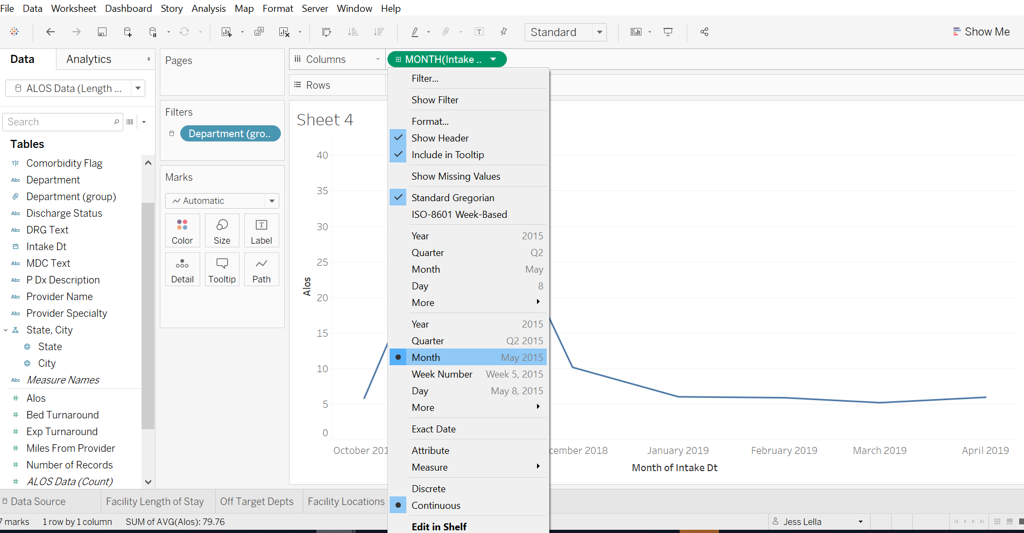  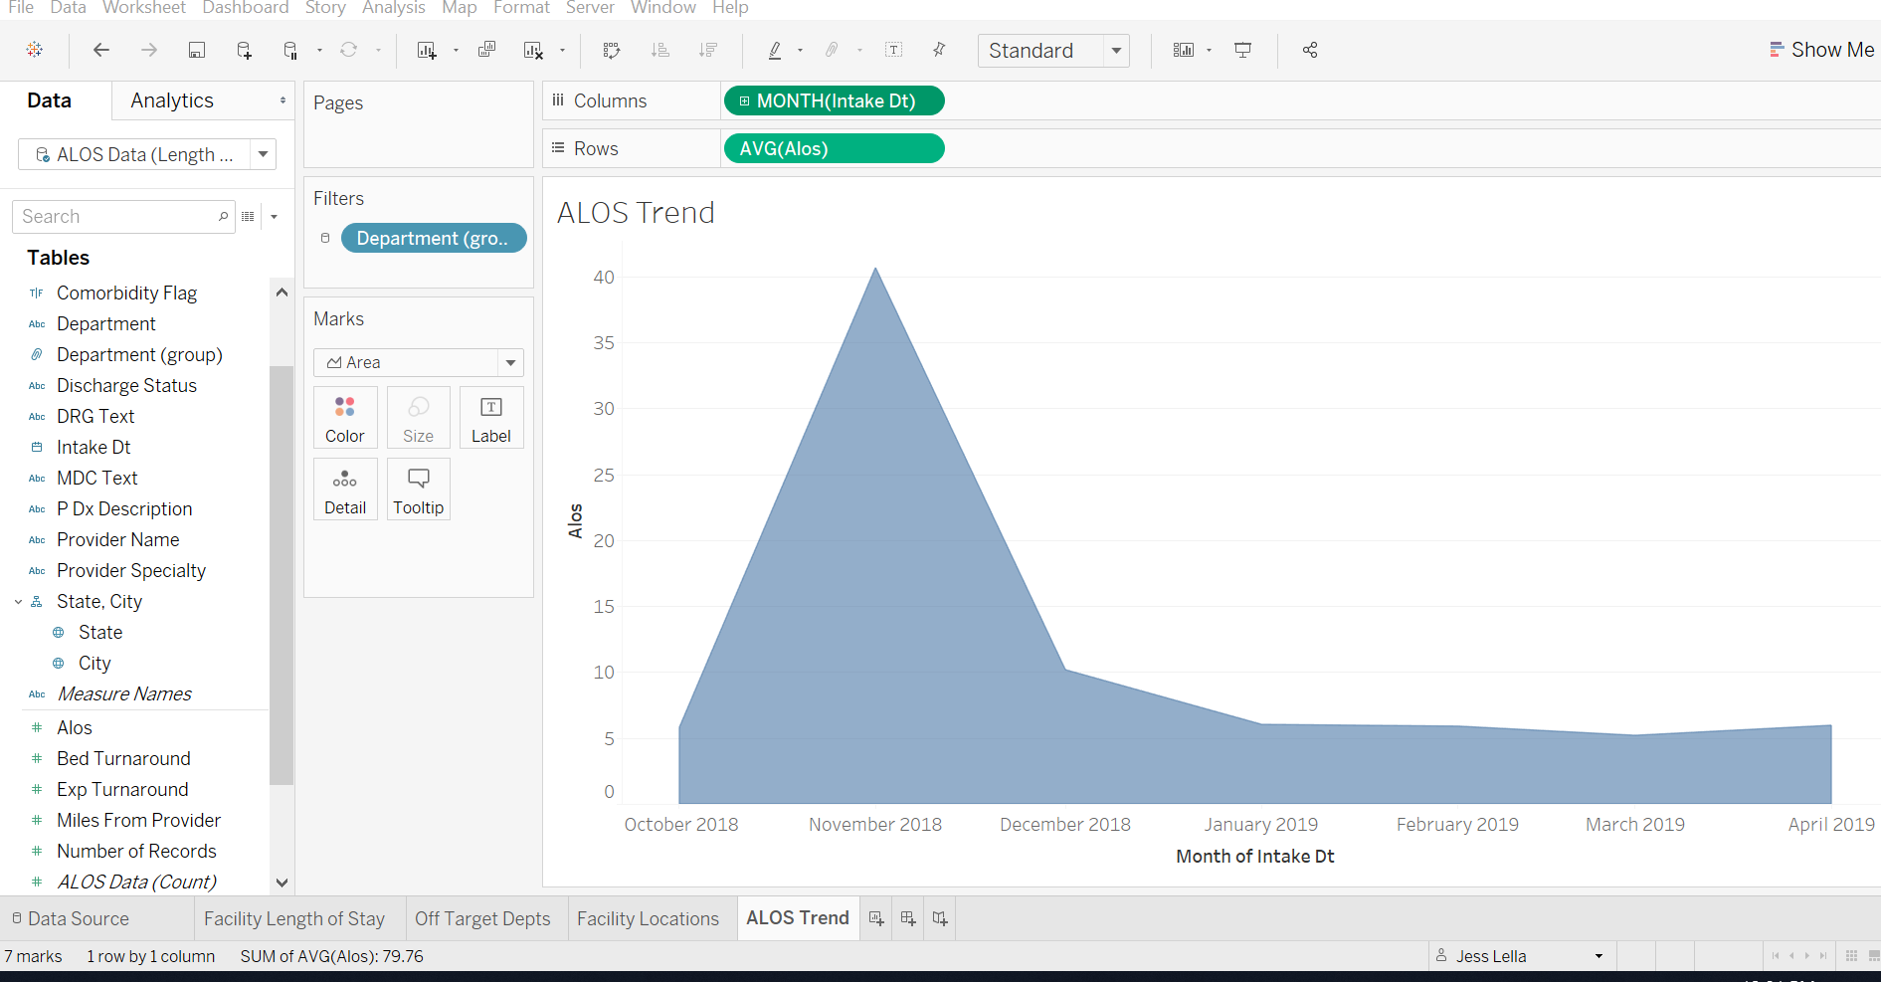

Exercise 5 – Telling a Story – Dashboards and Interactivity

We are done with our analysis and I want to be able to present my findings and share them with others in my organization.  Create a new dashboard. Click on the tab at bottom that looks like a window-pane.  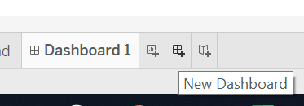  Name it ‘Length of Stay Analysis’.  Click on checkbox in lower left to ‘Show the Title’.  Let’s Add all of our sheets to the Dashboard by dragging them onto canvas.  Now we need to add interactivity, I may want to investigate by location, Department, Time etc…  Select any one of your sheets, click on the little funnel in upper right corner so it highlights white. Do this for all of your sheets.  Let’s start drilling into the details…  For Providence General facility located in Chicago, which Department and which DRG has the highest ALOS?  Depressive Neuroses in the Emergency Medicine | 